**TEST CASES**

**Software Testing:**

Software testing is known as a process for validating and verifying the working of a software/application. It makes sure that the software is working without any errors, bugs, or any other issues and gives the expected output to the user. The software testing process isn’t limited to finding faults in the present software but also finding measures to upgrade the software in various factors such as efficiency, usability, and accuracy. So, to test software the software testing provides a particular format called a Test Case.

**What Is Testcase:**

A test case is a defined format for software testing required to check if a particular application/software is working or not.

A test case consists of a certain set of conditions that need to be checked to test an application or software i.e., in more simple terms it checks if the resultant output meets the expected output or not.

A test case consists of various parameters such as ID, condition, steps, input, expected result, status, and remarks.

**Parameters of a Test Case:**

* **Module name -Subject or title**
* **test case ID - A unique identifier**
* **tester name -The name of the person who would be carrying out the test.**
* **test scenarios - a brief description to the tester.**
* **test case description - The condition required to be checked.**
* **test steps - Steps to be performed for the checking of the condition.**
* **Prerequisite - The conditions required before the start of the test process.**
* **test priority - the name suggests gives priority to the test cases.**
* **test data - The inputs to be taken while checking for the conditions.**
* **test expected result - The output which should be expected at the end of the test.**
* **test parameters - Parameters assigned to a particular test case.**
* **Actual result - The output that is displayed at the end.**
* **environment information - which the test is being performed.**
* **status - The status of tests such as pass, fail, NA, etc.**
* **comments - Remarks on the test**

**SAMPLE DOCUMENT FOR TEST CASE: TEMPLATE:**

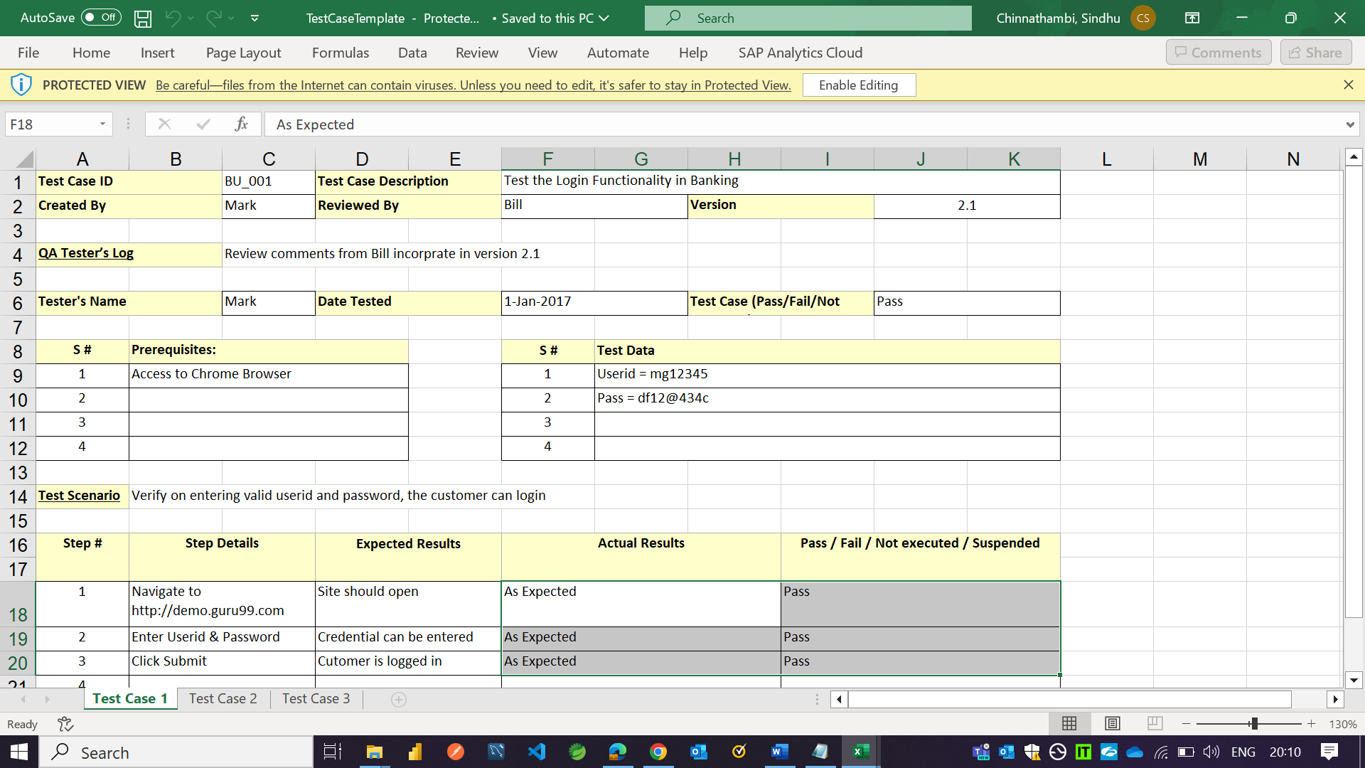

**While writing test cases, remember to include:**

A reasonable description of the requirement

A description of the test process

Details related to testing setup: version of the software under test, data points, OS, hardware, security clearance, date, time, prerequisites, etc.

Any related documents or attachments testers will required.

Alternative to prerequisites if they exist.

**Why We Write Test Cases?**

To check whether the software meets customer expectations.

To check software consistency with conditions.

Narrow down software updates.

Better test coverage.

For consistency in test execution.

Helpful during maintenance.

**Test Case Management Tools:**

TestCaseLab

PlusQA. ...

TestRail. ...

Kualitee. ...

Test Collab. ...

TestLodge. ...

**Types of Test Cases:**

Functionality Test Case Unit Test Case

Usability Test Case Unit Test Case

Integration Test Case Security Test Case

Performance Test Case User Acceptance Test Case

Database Test Case

Reference:

<https://www.geeksforgeeks.org/test-case/>

https://www.youtube.com/watch?v=Nj8D1PVqnVw